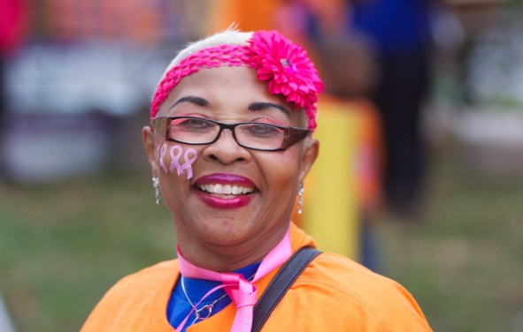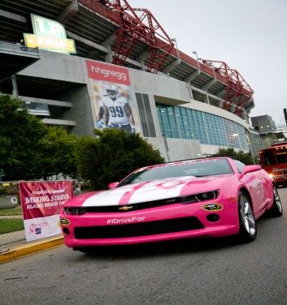

Our Making Strides walk may be over, but we are continuing to fundraise!
Help us finish October strong by taking the Pink Passion Week fundraising challenge. The team to raise the most money between October 27 and October 31 will win a spot for their team in the 2015 Pink Village, along with t-shirts for up to 25 team members and a chance for their team to be the first walkers to lead next year’s walk! The individual to raise the most money during Pink Passion Week will ride shotgun in the Chevrolet Pace Car during next year’s Making Strides walk!
The rules are simple:
- Host one or more fundraisers between October 27 and October 31. Only money raised during this time period will count towards the Pink Passion Week challenge. Money raised prior to October 27 will not be included in the total, so everyone has an equal chance to win. Money may be raised online or turned into our office.

Take a selfie of you or your team holding a sign showing the amount you raised and share it on our Making Strides Facebook page www.Facebook.com/MakingStridesNashville or Twitter @IAmStridesNash. Alternately, you can email your photo to nashvilletn.strides@cancer.org and we will post it for you. All photos must be submitted by Midnight on Friday, October 31 and money must reach our office by Friday November 7th. Money not raised online can be brought by our office Monday-Friday from 8:00 a.m. – 4:30 p.m. or mailed to:

American Cancer Society
Pink Passion Challenge
2000 Charlotte Avenue
Nashville, TN 37203

- Remember, you must submit a photo to be eligible.

- The winners will be announced on November 14th.

